**CONTENTS**

**EXECUTIVE SUMMARY 2**

**INTRODUCTION 3**

**METHODOLOGY 4**

**LIMITATIONS 8**

**FINDINGS 9**

CUSTOMER SURVEY 10

BUSINESSES 10

JOB SEEKER FINDINGS 11

SECRET SHOPPER OVERALL FINDINGS 12

POSITIVE THEMES 12

OPPORTUNITIES FOR IMPROVEMENT 14

INDIVIDUAL CENTER FINDINGS 16

AIKEN 17

CONWAY 19

COASTAL 21

GREENVILLE 23

**RECOMMENDATIONS 25**

**APPENDIX 27**

Appendix 1 27

Appendix 2 28

Appendix 3 29

# EXECUTIVE SUMMARY

# INTRODUCTION

Hjhlhklhjkljh

hklhjlhlhjlhl

# METHODOLOGY

Hjknlkhnklhl

Hjjhljhlhlhj

**2**

Selection of Pilot

Sites to Assess

**3**

Development of data

collection strategy

**4**

Job Seeker and

Business Survey

**5**

Secret Shopper

Recruitment

**6**

Training of Secret

Shoppers

**7**

Site Visits and

Data Collection

**1**

Kick-Off Meeting and

Background Data Review

Individual between the ages of 22-32 with a high school diploma, looking for trade skills and full- time employment.

Person with substantial work experience and limited English proficiency who is looking for a career change due to reasons such as underemployment.

A person with bachelor’s degree from an accredited University who has been out of work due to certain reasons such as layoff during COVID or

relocation to a new city and is looking for a new job.

Profile 2

Profile 3

Profile 1

# LIMITATIONS

Hjlhjlhjlhlhjkhjlh

hjlhlhjlhlhjklhlk

# FINDINGS

## CUSTOMER SURVEY

hjhjhjhjhjh

### BUSINESSES

Hklhlk

ghgk

### JOB SEEKER FINDINGS

Hjhjhjhjh

Hjhkjlhl

hjkh

|  |  |  |
| --- | --- | --- |
| **hjhjh** |  |  |
|  |  |  |
|  |  |  |
|  |  |  |

## SECRET SHOPPER OVERALL FINDINGS

### POSITIVE THEMES

hjhjhjhjhjhjhjh

### OPPORTUNITIES FOR IMPROVEMENT

hjhjhjhj

jkjkjkjkjk

|  |  |  |
| --- | --- | --- |
| **Hjhjh** |  |  |
|  |  |  |
|  |  |  |
|  |  |  |

## INDIVIDUAL CENTER FINDINGS

### A blue outline of a state Description automatically generatedAIKEN

Hjkhjl

**SURVEY SUMMARY**

Donec quis erat et quam iaculis faucibus at sit amet nibh. Vestibulum dignissim lectus in ligula rhoncus jklmnk;

**SECRET SHOPPER SUMMARY**

Hjhhjh

ghkjh

|  |  |  |
| --- | --- | --- |
| **hjhjh** |  |  |
|  |  |  |
|  |  |  |
|  |  |  |

### CONWAY

hjhjhjhjhjh

hjhjhj

**SURVEY SUMMARY**

Hjhjhjhjh

hjhjhjhjhj

**SECRET SHOPPER SUMMARY**

Hjhjhjhj

Hjhjhj

|  |  |  |
| --- | --- | --- |
| **hjhjh** |  |  |
|  |  |  |
|  |  |  |
|  |  |  |

### A blue outline of a state Description automatically generatedCOASTAL

Hjhjhjhjhj

hjhj

**SURVEY SUMMARY**

Hjhjhjhjhj

hjhjhjhjhj

**SECRET SHOPPER SUMMARY**

Hjhjhjhjhjhjh

Hjhjhjhjhj

|  |  |  |
| --- | --- | --- |
| **hjhjh** |  |  |
|  |  |  |
|  |  |  |
|  |  |  |

### GREENVILLE

hjhjhjhj

**SURVEY SUMMARY**

Hjhjhj

gjhgk

**SECRET SHOPPER SUMMARY**

Hjkjh

Hjkhjk

|  |  |  |
| --- | --- | --- |
| **hjhjh** |  |  |
|  |  |  |
|  |  |  |
|  |  |  |

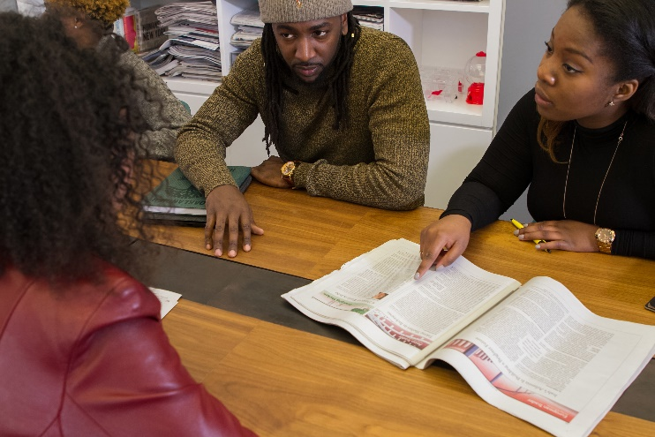

# RECOMMENDATIONS

jkjkjkjkjk

# APPENDIX

jkjkjk

### Appendix 1

jkjkjk

### Appendix 2

Jkjkjk

### Appendix 3

jhkl

**ACKNOWLEDGEMENTS**

